IT 697 SQL Module Five Reflection Journal

Michael Surdek

Southern New Hampshire University

The fifth week of this course was a little bit of a different experience than previous weeks have been. The first reason for this is that the module introduction did not contain resources to guide my initial exploration of SQL functions, and there was also no discussion page which typically offers guidance as well as the ability to interact with my peers and hear about their experiences and feedback. Another reason this week was more of a challenge is that I was previously familiar with the clauses that we covered in weeks 1-4, but I had never before seen functions being used in SQL. These things caused me to feel somewhat lost at the beginning of the week. I was not exactly sure where to begin, but my experience so far in this course has shown me that I just needed to start looking for resources and let them guide my experience. Despite these challenges, I was able to find many useful resources that helped me learn about SQL functions and I was able to spend time practicing writing queries involving functions to solve practice problems using a database on movie rentals.

I spent the first few days exploring youtube and google for videos and webpages that might be helpful during this week’s learning experience of SQL functions. I watched a video that provided an introduction to functions in SQL and I learned about some of the built-in functions as well as the capability of creating and incorporating custom functions. I also browsed the subreddit r/SQL for threads related to functions or other topics that we have covered in prior weeks. Some threads that I found useful included “where clause to combine multiple ANDs…” and “Advice on SQL for Beginners.” Reading through the subreddit and these threads in particular is a great way to hear from SQL users of all experience levels and to be introduced to more advanced topics that build on some of the simple clauses that we have been introduced to. My final activity from the early part of the week was reading an article/walkthrough titled “4 Essential SQL Window Functions and Examples for a Data Scientist Interview in 2021” by Leon Wei of sqlpad.io. The walkthrough explained and showed examples of four different types of SQL functions that work in conjunction with OVER and PARTITION BY. Some of these functions are similar to the aggregate functions used with the GROUP BY clause, but the difference is that a calculated column is added and every row from the table is retained unless otherwise specified. Learning about these functions was a good way to build on what we learned in the GROUP BY module. I vaguely understood how these functions can be used to solve and provide information for many common questions, but the best part about the website sqlpad.io is that it offers sample questions with a movie rental database and it provides a coding environment which compares your query’s results to the expected results that answer the question.

On Friday, I created a sqlpad.io account and utilized the coding environment to attempt to answer the practice questions related to Window functions such as sum, avg, and max. I tried for about an hour but was not able to generate the expected results, due to issues both with the Window functions and with more basic join and group by operations.

After a couple days of letting my struggles with the practice questions sink in, I found a brief podcast from the Programmers Quickie Podcast titled “SQL Window Functions (OVER, PARTITION BY)” and it turned out to be exactly what I needed to grow my understanding of Window functions. After listening to the podcast, I was able to re-attempt the same practice question and correctly write a query that generated results showing the revenue percentage from the top 10 films by film ID. The coding environment and my results are shown in the screenshot below. The left side shows the question and the relevant tables as well as the expected results. The right side shows the query I wrote and the results in produced, which are identical to the expected results. The bottom says “Wow, you nailed it! Awesome!”

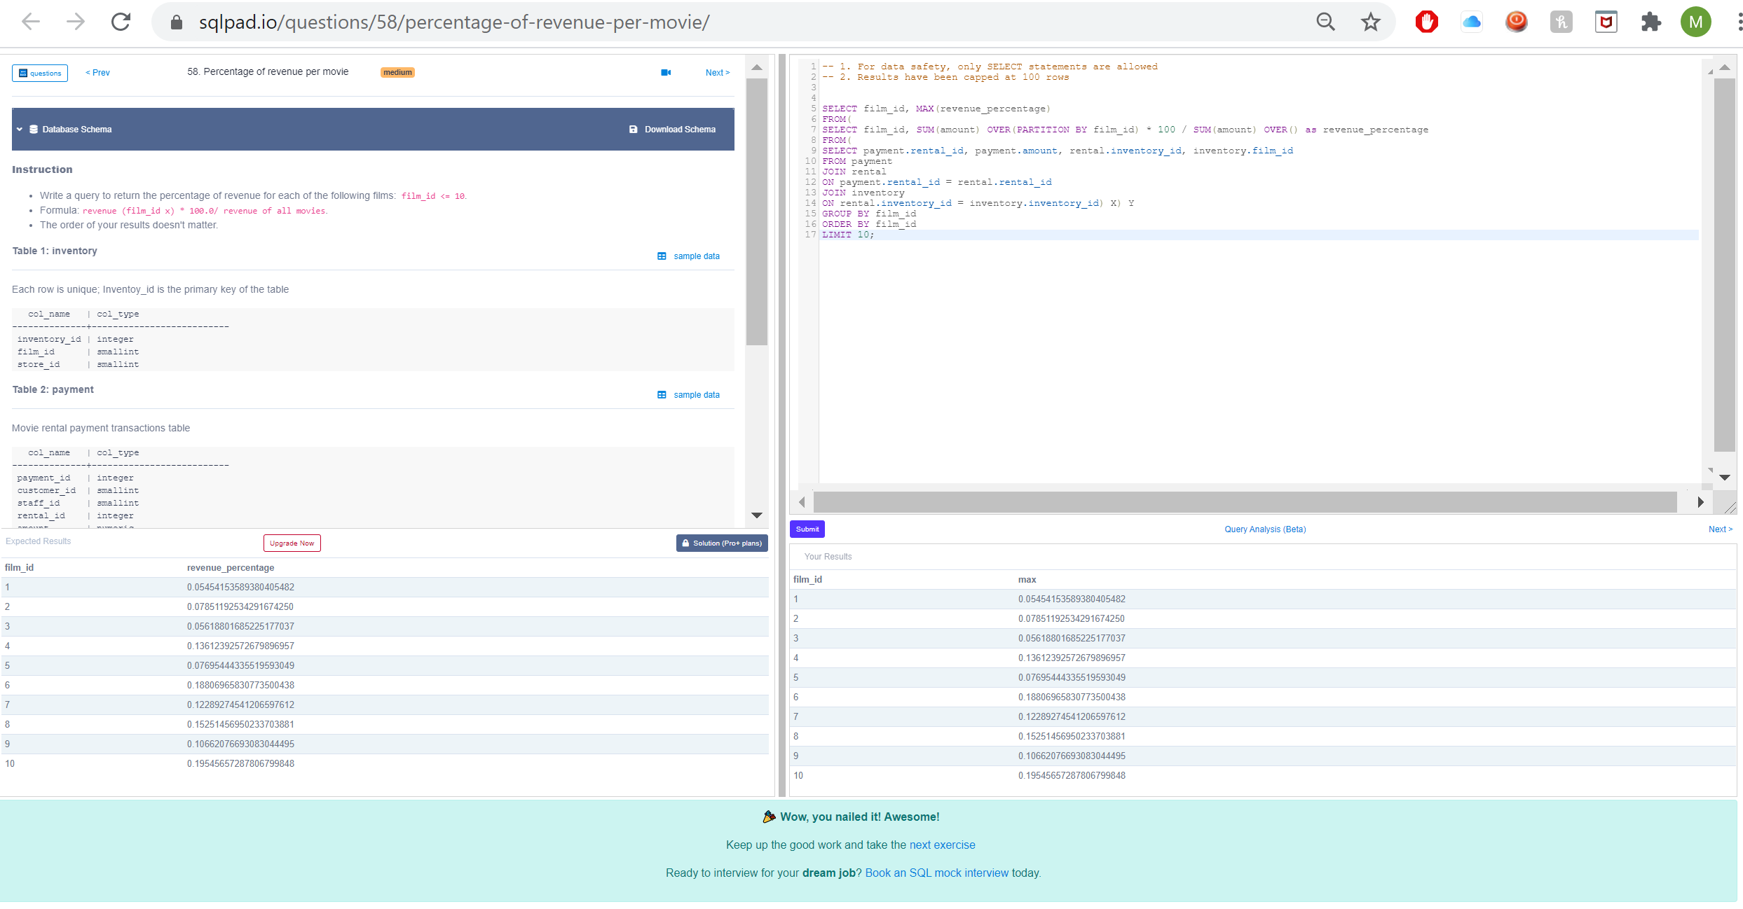

At this point I decided to attempt another question that used a different Window function, row_number. I was able to write a query that generated results showing the shortest film in each category.

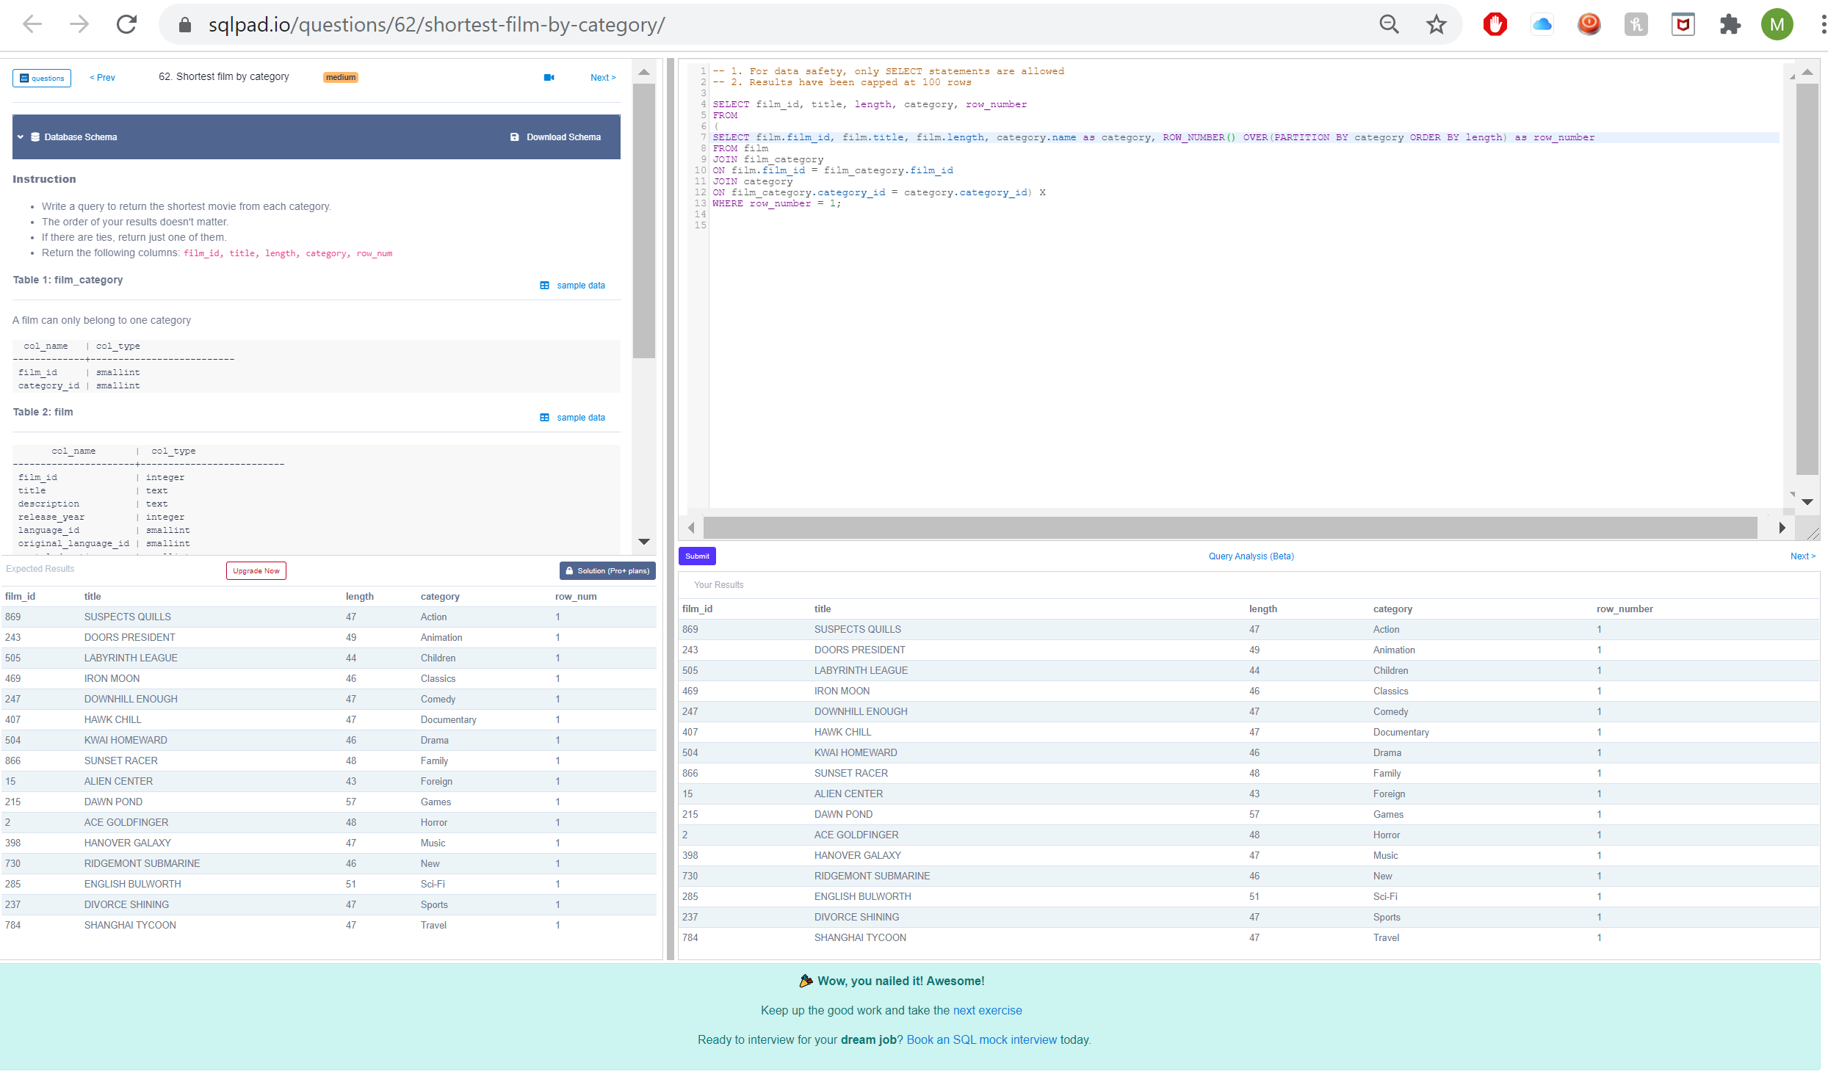

I found out that there are 90 practice question available on sqlpad.io and you can earn points by answering questions based on their difficulty. Leon sends out a weekly progress report which shows the top 10 leaders in points for the given month. I intend to use these questions to practice writing SQL queries that answer questions, and my goal is to be on the top 10 list in terms of points accumulated during the month of April.

References

Wei, Leon. “4 Essential SQL Window Functions and Examples for a Data Scientist Interview in

2021” Sqlpad.io. 2021. Retrieved from <https://sqlpad.io/tutorial/4-essential-sql-window->

functions-and-examples-for-a-data-scientist-interview-in-2021

Project/Coursework Tracker

* Company requirements -> database schema
  + Started in week 4 with the database design podcast
* Live scoreboard/rankings of some kind
  + Not started
* Fitness plan recommendations
  + Planning to start in week 6
* Sqlpad.io movie rental practice questions
  + 2/90 completed